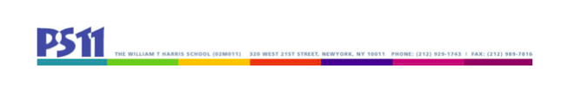
SLT Meeting
4.18.23
3 – 3:25

Attendance:
Bob Bender, PS 11 Principal
Teachers:
Emma Balmuth-loris
Deborah Forschein
Marketa Kawa
Jamie Schissel
Holli Weiss (UFT Chapter Chair)
Parents:
Inbar Aricha-Metzer
Rebecca Berkebile (Secretary)
Francesca Granata
Brad Hargreaves
Courtney Lewis (Chair)
Absent:
Debbie Osborne, PS 11 Programs and Community Based Organization (CBO) representative
Alexandra Cordero

Minutes:

- Family Engagement
Literacy Partners – may have to wait until next year
The Science of Reading program through Literacy Partners – Mr. Bender is not interested at this point

- Health & Safety (including mental health)
- Look for outside speaker to discuss online safety with students/families for next year
- Social/Community Engagement
- Potluck (June 23, 2023 – 6-7:30pm) – Mr. Bender requested volunteers through the PTA and asked the PTA to request police presence at the event; PTA approved ordering inexpensive pizzas; at the next SLT meeting, we will finalize our schedules/tasks.

- SLT Enrichment Proposals
No new proposals.

- Word on the Street
- Food has gotten worse in the cafeteria – only one menu option – this is in the hands of the mayor.
- Nuts are not allowed in the classroom, but can be packed for lunch – school asks that caregivers try not to do this, though.
- Comprehensive Education Plan
SLT members should review the CEP document before we meet again in May – the new draft will be posted on April 20, 2023.
Mr. Bender will gather data on how students are doing this year, though the school has changed drastically from last year to this year, so we will have to consider adjusting goals with this in mind.
District 2 will have a mandated ELA curriculum beginning in the 2024-2025 school year.

- Adjourn

Next meeting: Tuesday, May 9, 3-4:30pm

